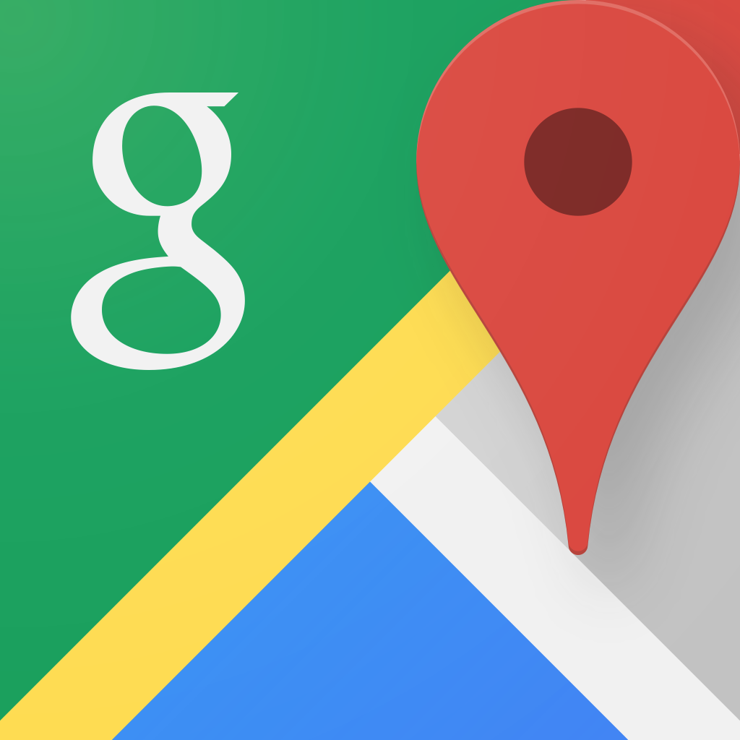Google Maps:

The Google Maps app makes navigating your world faster and easier. Find the best spots in town and the information you need to get there. It is comprehensive, accurate maps in 220 countries and territories and has street view and indoor imagery for restaurants, museums, and more. But its arrow doesn’t often direct a way instantly. The general situation is when we try to walk a little way, we find we are going to the opposite direction. It bothers us a lot.

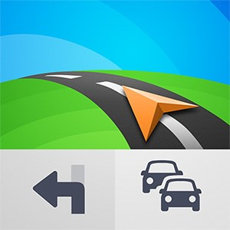GPS Navigation & Maps Sygic:

GPS Navigation & Maps gets the most of the navigation, upgrade to premium and enjoy high-end lifetime features: 3D maps, real-time turn-by-turn voice-guided navigation, lane guidance, speed limit warnings & junction view with lane indicator arrows at complex intersections. But the problem is we need enough storage to store the offline map data information.

Waze:

Waze is the world's largest community-based traffic and navigation app. Join other drivers in your area who share real-time traffic and road info, saving everyone time and gas money on their daily commute. However, it isn't really necessary for simple navigation. Commuters probably love the app, but we don't need an app doesn't have the nicest and smoothest interface to drive 20 minutes on Brooklyn.